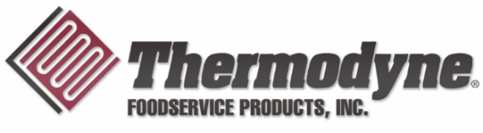

**FOR IMMEDIATE RELEASE**

*For the foodservice, catering and restaurant industries.*

**Thermodyne Foodservice Products Launches New Equipment at NAFEM Show**

Fort Wayne, IN – (Feb. 25, 2025) Thermodyne Foodservice Products announces the company will unveil new equipment for the first time in its recent history at The North American Association of Food Equipment Manufacturers (NAFEM) Show in Atlanta. The show runs Feb. 26-28.

Thermodyne will showcase its all-new Rapid Thawing Cabinet at the show, which utilizes conduction and convection to produce faster thaw times than any competing equipment in the market.

“The Rapid Thawing Cabinet really is a game changer for kitchens, and we can’t wait to show it off at NAFEM, the premier event for foodservice manufacturers,” says Thermodyne National Sales Representative Aaron Bremer. “We have a lot of great products that help produce great results in kitchens across the world, and I look forward to sharing them with show attendees.”

Bremer will represent Thermodyne at Booth No. 6012, where the company will also showcase several models of its Precision Temperature Technology cabinets and steam table series.

Headquartered in Fort Wayne, Ind., Thermodyne Foodservice Products offers more than 35 pieces of equipment that utilize Precision Temperature Technology. These products are tailored to businesses specializing in foodservice and catering.

Thermodyne’s extensive product range offers flexibility to meet each kitchen’s individual needs and aids culinary staffs in preparing excellent food.

Much of Thermodyne’s equipment is available for same-day shipment across the nation, and equipment can be customized to meet a customer’s specific needs and requirements.

For more information about Thermodyne and its revolutionary method of transfer heat technology, visit [tdyne.com](http://www.tdyne.com).

**About Thermodyne**

Founded in 1987, Thermodyne Food Service Products, Inc. specializes in the manufacturing of both countertop and [full-sized slow cook and hold ovens](https://tdyne.com/products/category/slow-cook-and-hold-full-size/). Each unit features Thermodyne’s patented Fluid Shelf Technology, in which low-temperature heat is transferred throughout each shelf rather than through the air. This not only ensures food quality and safety, but also allows food products to be held for extended periods. For more information, call 888-310-7352 or visit [tdyne.com](https://www.tdyne.com).